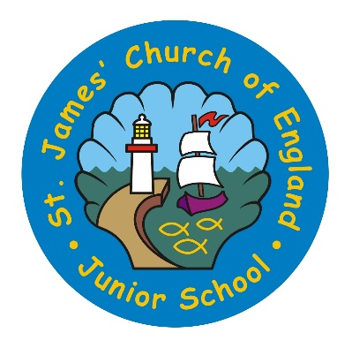
St James’ Church of England Junior School
Wellington Row, Whitehaven, Cumbria, CA28 7HG
Tel. 01946 695311
Email: admin@stjamesjun.cumbria.sch.uk
Website: stjamesjun.cumbria.sch.uk

Headteacher: Mr Andrew Beattie

“With exploring minds, and faith; we grow and learn together.”
Parent Survey Analysis

- My child is happy at this school
Strongly agree 75.29% Agree 23.53% Strongly disagree 1.18%

- My child feels safe at this school
Strongly agree 82.56% Agree 15.12% Don’t know 1.16% Strongly disagree 1.16%

- My child makes good progress at this school
Strongly agree 59.52% Agree 38.10% Don’t know 1.19% Strongly disagree 1.19%

- My child is well looked after at this school
Strongly agree 73.26% Agree 25.58% Strongly disagree 1.16%

- My child is taught well at this school
Strongly agree 67.44% Agree 31.40% Strongly disagree 1.16%

- My child receives appropriate homework for their age
Strongly agree 42.35% Agree 52.94% Disagree 3.53% Strongly disagree 1.18%

- This school makes sure its pupils are well behaved
Strongly agree 53.49% Agree 43.02% Don’t know 2.33% Strongly disagree 1.16%

- This school deals effectively with bullying
Strongly agree 45.35% Agree 19.77% Don’t know 33.72% Disagree 1.16%
P.T.O

- This school is well led and managed
Strongly agree 73.42% Agree 25.32% Strongly disagree 1.27%

- This school responds well to any concerns I raise
Strongly agree 64.56% Agree 21.52% Don’t know 11.39% Disagree 1.27% Strongly disagree 1.27%

- I receive valuable information from the school about my child’s progress
Strongly agree 50% Agree 42.50% Don’t know 5% Disagree 1.25% Strongly disagree 1.25%

- Would you recommend this school to another parent?
Strongly agree 75% Agree 20% Don’t know 2.5% Disagree 1.25% Strongly disagree 1.25%

